**Unit 6 Lab – Introduction to Websites/Web Applications**

**Exercise 1 – Information Architecture**

The purpose of this exercise is to expand your knowledge of the process involved in building an Information Architecture for a website. The slides in this unit provide a basic introduction the subject. And so before you start review the content in to the following study guide and case study.

* [Information Architecture: Study Guide](https://www.nngroup.com/articles/ia-study-guide/)
* [Case Study About Information Architecture](https://bootcamp.uxdesign.cc/another-case-study-about-information-architecture-f694862c5a78)

Armed with this information, pick a local website which you use on a regular basis and conduct a basic information mapping exercise using the following headings/questions. Don’t pick a large website as it’s more likely to have less identifiable issues due to the increased investment in it’s design and implementation. Smaller websites will have more easily identifiable issues.

1. Who are the typical users of the website? (2-3 max) Give a short description for each
2. Organization system
3. Labelling system
4. Navigation system
   1. Header design and main site navigation (both desktop and mobile)
   2. Footer design
5. Searching system
6. Top tasks & User flows
   1. What are the top tasks (max 5) for the website?
   2. How well would you rate the design in relation to these tasks?
   3. Identify any major issues
7. Overall page design and layout

Using these headings and questions review the website to identify it’s target audience and whether you think the website addresses their needs in terms of it’s IA, visual design and implementation. Recommend fixes or solutions to address the top 2-3 issues you identify.

**Exercise 2 – Component Design**

The previous exercise (unit 5) involved the creation of a layout for a webpage. The design included a set of four cards consisting of an image, an overlay heading/title and some text.

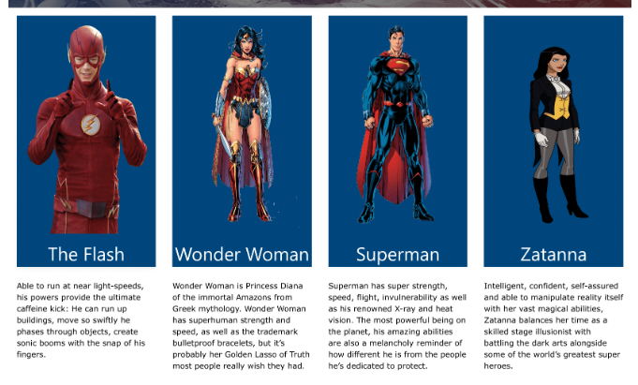

Create a Cards component (html & CSS) to meet the following requirements:

* Each card will contain an image, overlay title/text and some paragraph text
* Cards are to be arranged in a horizontal grid ranging from 4 to 1 cards depending on the viewport size
* The complete card should be “clickable”, i.e. the user can click on any part of the card to go to the linked content
* Be fully responsive. The card should expand to the available space. So for example if viewed on a mobile device the card should be full width while on a desktop it should have a maximum width depending on the viewport width. If a card can’t fit on a row then it should overflow automatically to the next row
* Either Flexbox or CSS Grid can be used

**Exercise 3 – Building DC Comics website using the Astro Framework**

Building on the DC Comics exercise which you completed in unit 5 plus the Cards component which you built in the previous exercise, we now want to take that completed HTML and CSS and repackage it to work within the Astro framework and making use of it’s many features. By doing this we can then use it to create a multi-page static website which can then be deployed to GitHub Pages

1. Create a new GitHub repository for this exercise
2. In the local repository create a new Astro project. Note you will need to install npm if you haven’t done so previously
3. Using the existing HTML, create the following components:
   1. Header
   2. Footer
   3. Banner – this is just the large image
   4. Navbar
   5. Cards (using your code from previous exercise)
4. Create a page layout consisting of the header, navbar, banner and footer components
5. Create a homepage and add the table content to it
6. Create three other pages for the links in the navbar using the page layout and add dummy text content content to each

Note: this is an important exercise as you will be using the Astro framework to build the website in the final course assessment

Additional information:

* <https://docs.astro.build/en/tutorial/0-introduction/>
* <https://bejamas.io/blog/practical-guide-to-astro-js-framework/>